**Practical No. 9**

1. **Working with Notification in Android**

**Designing UI**

**Activity_main.xml**

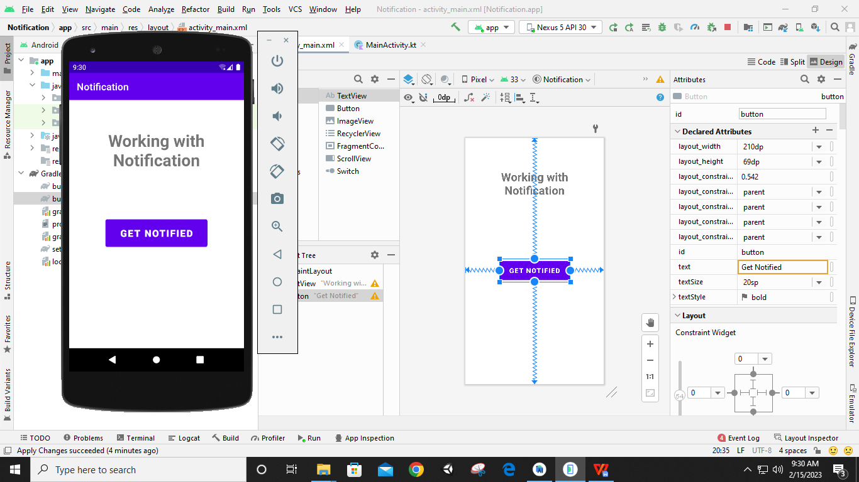

**Activity_KT_Timetable.xml**

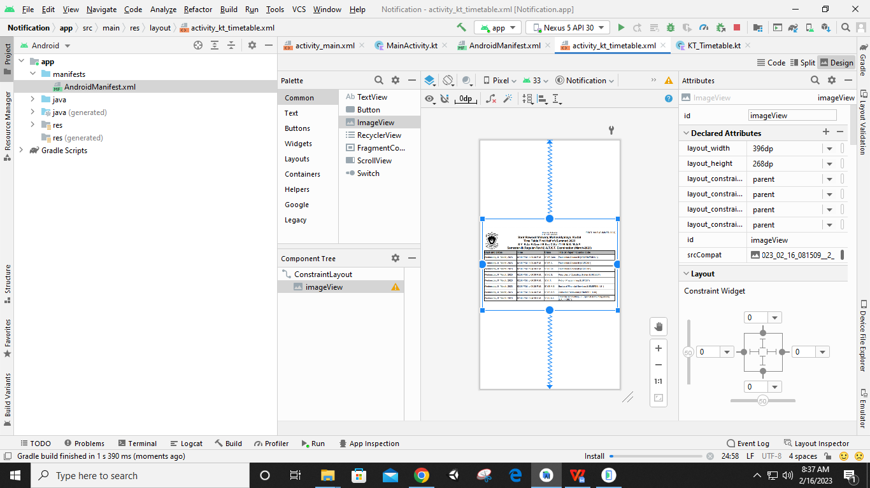

**Code:**

**MainActivity.kt**

**package** com.example.notification  
  
**import** android.app.Notification  
**import** android.app.NotificationManager  
**import** android.app.PendingIntent  
**import** android.content.Context  
**import** android.content.Intent  
**import** androidx.appcompat.app.AppCompatActivity  
**import** android.os.Bundle  
**import** android.widget.Button  
  
**class** MainActivity : AppCompatActivity() {  
 **override fun** onCreate(savedInstanceState: Bundle?) {  
 **super**.onCreate(savedInstanceState)  
 setContentView(R.layout.*activity_main*)  
  
 **var** btn:Button=findViewById(R.id.*button*)  
  
 btn.setOnClickListener() **{  
 var** intent1:Intent = Intent(**this**,KT_Timetable::**class**.*java*)  
 **var** pi:PendingIntent = PendingIntent.getActivity(**this**, 0, intent1, 0)  
  
 **var** n: Notification =Notification.Builder(**this**)  
 .setTicker(**"Notification from CS Department"**)  
 .setContentTitle(**"Sem III ATKT Exam"**)  
 .setContentText(**"Sem III ATKT Practical Exam starts at 27th Feb"**)  
 .setSmallIcon(R.drawable.*ic_launcher_background*)  
 .setContentIntent(pi).build();  
  
 **var** nm: NotificationManager = getSystemService(Context.*NOTIFICATION_SERVICE*) **as** NotificationManager  
 nm.notify(1, n)  
 **}** }  
}

**AndroidManifest.xml**

*<?***xml version="1.0" encoding="utf-8"***?>*<**manifest xmlns:android="http://schemas.android.com/apk/res/android"  
 package="com.example.notification"**>  
  
 <**application  
 android:allowBackup="true"  
 android:icon="@mipmap/ic_launcher"  
 android:label="@string/app_name"  
 android:roundIcon="@mipmap/ic_launcher_round"  
 android:supportsRtl="true"  
 android:theme="@style/Theme.Notification"**>  
 <**activity  
 android:name="com.example.notification.KT_Timetable"  
 android:exported="true"** />  
  
 <**service  
 android:name=".MyService"  
 android:enabled="true"  
 android:exported="true"** />  
  
 <**activity  
 android:name=".MainActivity"  
 android:exported="true"**>  
 <**intent-filter**>  
 <**action android:name="android.intent.action.MAIN"** />  
  
 <**category android:name="android.intent.category.LAUNCHER"** />  
 </**intent-filter**>  
 </**activity**>  
 </**application**>  
  
</**manifest**>

**KT_Timetable.kt**

**package** com.example.notification  
  
**import** androidx.appcompat.app.AppCompatActivity  
**import** android.os.Bundle  
  
**class** KT_Timetable : AppCompatActivity() {  
 **override fun** onCreate(savedInstanceState: Bundle?) {  
 **super**.onCreate(savedInstanceState)  
 setContentView(R.layout.*activity_kt_timetable*)  
 }  
}

**Output:**

